NFIT conference 2020, 17.march: How to get there
It is a nice 20min walk between Scandic (Rica) Nidelven hotel and «Laboratoriesenteret», Øya, St.Olavs hospital:
Route1: “Trondheim in a nutshell” Route 2: “Fast-track with cathedral close-up”
Through “old town” Bakklandet and along the river More traffic, a bit faster
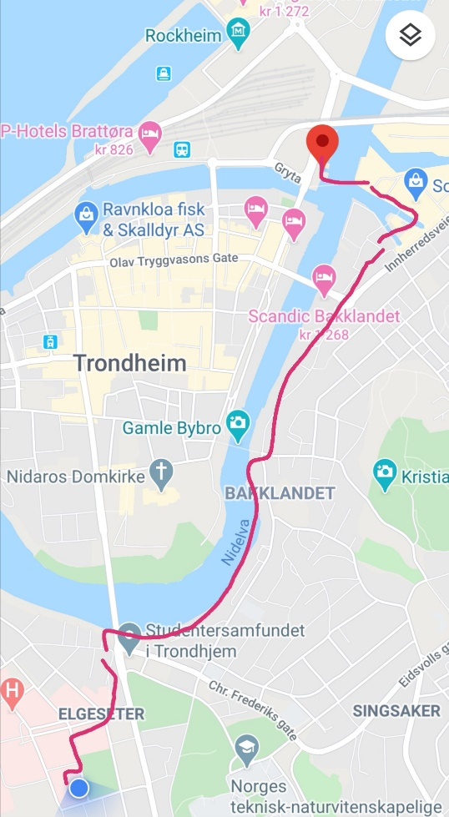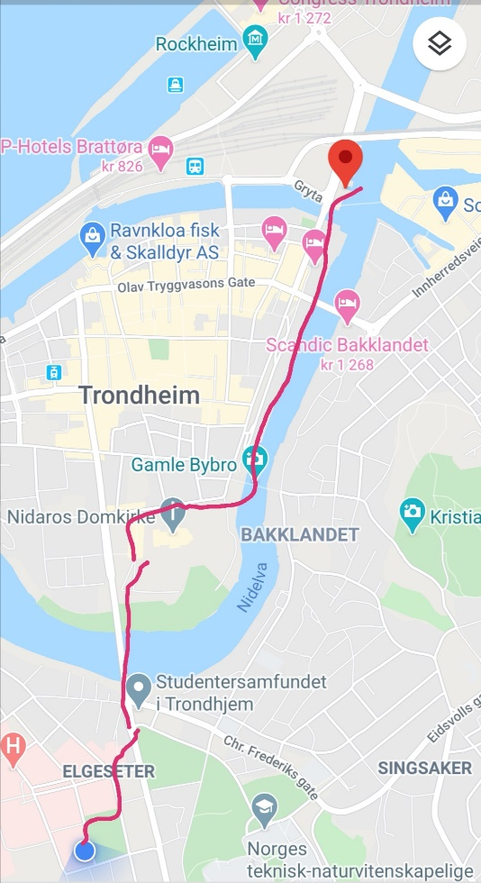

We will be starting up in LS41, 4th level, on the “bridge” between the two arms of the “Laboratoriesenteret” building.
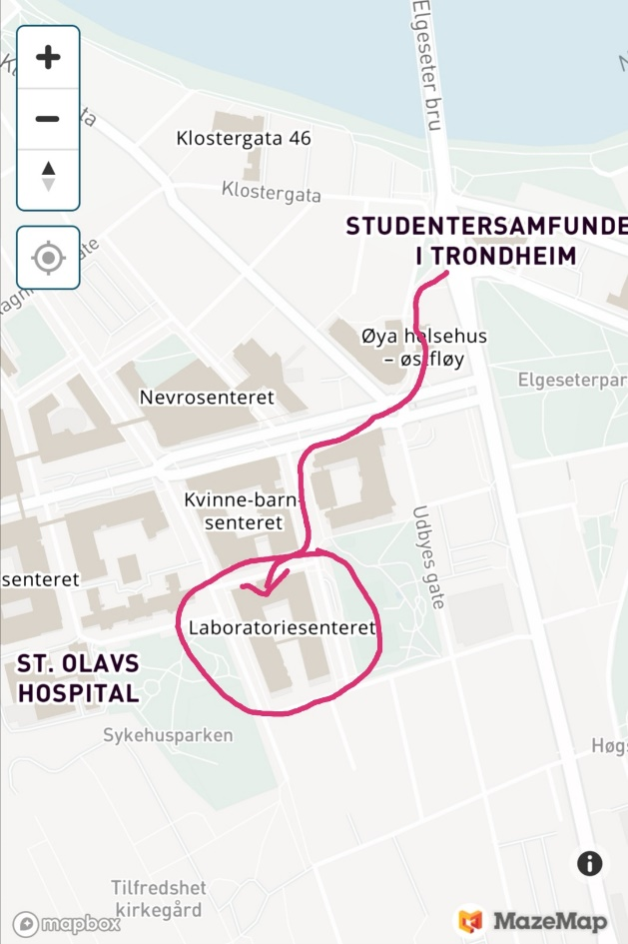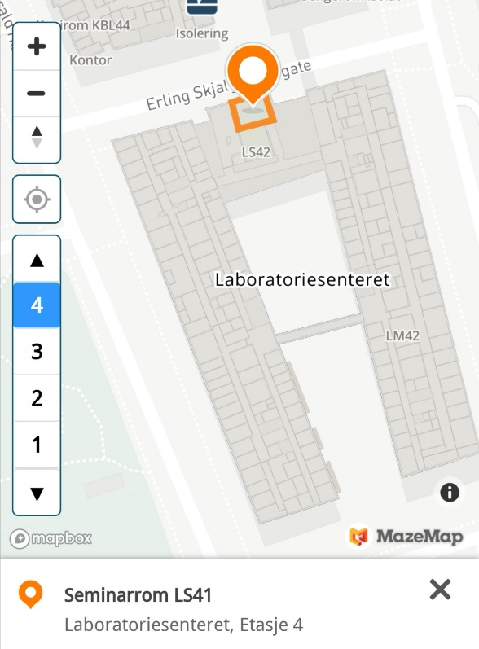
The “celleterapi” group will stay in LS41 after the registration, other groups will find their rooms here:
“Flow” group: LM21 “Immunhematologi” and “Blodberedskap” groups KBS21(a, b)

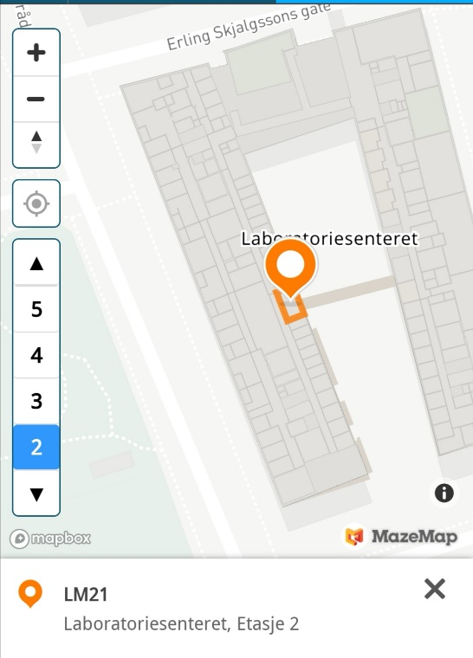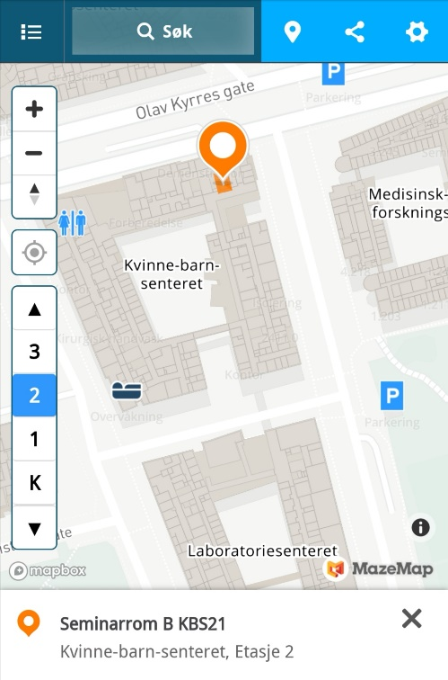

“Allergi” group
